Dear parents and caregivers,
This is without a doubt a very concerning time in our world and individual lives. As adults, we have concerns for safety and our children even more so. They will look to us for reassurance, guidance and depend upon us for emotional and mental health support. Please be patient with your children. They are not mature enough to handle the reality of this type of circumstance. We too as adults will struggle, yes, but these young minds we are now entrusted to care for in a different manner need us to lead them. To accept them for the social struggles they will encounter being isolated from peers. Especially those already faced with behavior and physical challenges. Be mindful of their nutrition as it can affect the ability to learn, to get adequate sleep, and thus balance emotions and behavior. Sound advice for us all.
Teachers will experience a sense of withdraw as well not being with their students. And vice versa. Online chatting can serve as a helpful tool to keep teacher and student connected socially. Snail mail can be re-invented to become pen pals when internet access is limited.
Your school staff continue to be great sources of support. Many companies have stepped up offering online modules for academic support and options to keep students engaged. I hear schools are working with community partners to ensure meals are provided to those in need. Reach out to your school for information if necessary.
To say this is a unique time in history is an understatement. It is imperative we look to one another for support and trust in the Lord to lead us through this. Daily prayer will continue to be a welcomed source of faith, strength and mental and emotional serenity. -Catholic Schools Office Preschool staff
Follow the “Catholic Schools- Diocese of Toledo” Facebook page too for support!

“Do not be anxious about anything, but in every situation, by prayer and petition, with thanksgiving, present your requests to God. And the peace of God, which transcends all understanding, will guard your hearts and your minds in Christ Jesus.” ~ Philippians 4:6-7

Preschool Resources for Parents and Caregivers
Updates on the COVID-19 in Ohio can be found here
Ohio Department of Education COVID19 Updates
Keeping a sense of structure and routine to a child’s day is helpful in easing anxiety about something new or unpredictable. We encourage parents/caregivers to create a daily routine chart of some kind to aide in providing young children a visual aide to follow each day (see examples included below).

What can preschool teachers do to help?
- Programs can provide examples of daily routine charts
- Programs can share lesson plans with parents/caregivers to guide and suggest activities
- Provide online resources parents to help guide engagement (see below)
- Share photos of centers from the classroom as examples of activities
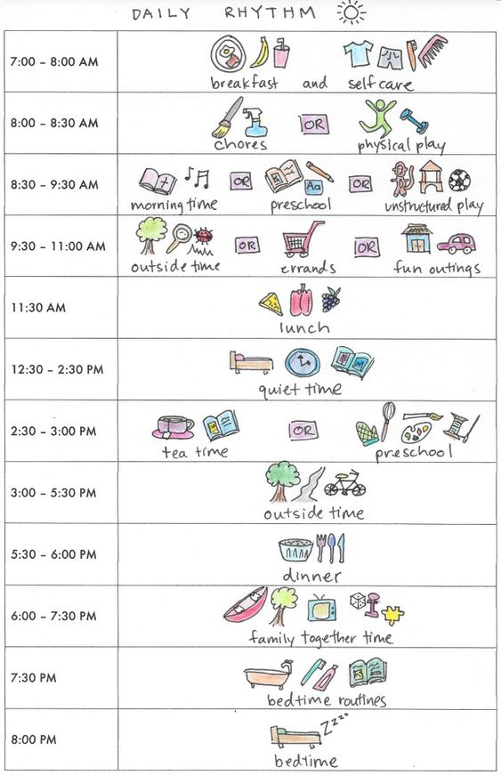
Daily Routine Chart examples:
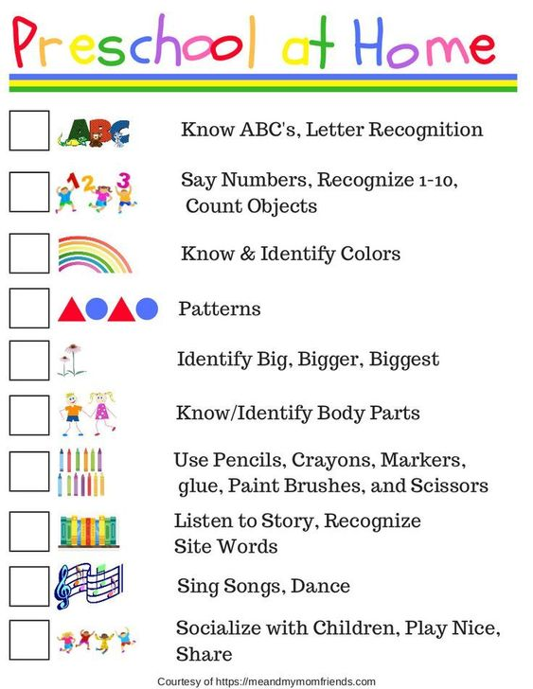
Regular daily activities that promote early learning development:
-Use a spiral notebook at home to collect the evidence of daily practice by writing or drawing pictures of what was experienced.
Literacy | Tracing/Writing own name and family name; write/draw out grocery list; | Heidi Songs  Sesame Street
Math | Counting any household items; stacking items; scavenger hunt to measure items in homes; sorting coins; matching games; creating patterns; dominoes; puzzles (spatial reasoning) | Ohio Dept of Ed Early Learning Guide
Science & Discovery | Cooking/baking; caring for plants; planting seeds for spring gardens; water play with measuring cups/food color; painting; playdough; stamp letters on playdough with Legos; | Germ video  Preschool STEAM
Social Interactions  *Critical for those more isolated during this time | Family game time; minute-to-win-it games; calling family & friends opposed to texting; video chatting-Google hangout with classmates; charades; | PBS  Emotion Charades  Conversation starters (image below)
Physical Growth | Outdoor play  Inside play: rolling balls, walking a “line” created with socks, tape; hopping on one foot; exercise videos; dance party; free online instructional videos to learn new skills like tai chi; helping with groceries, folding laundry; cleaning-raking, car washing, sweeping; | Indoor Recess  More Indoor Recess
Religion | Attend mass if appropriate; read from a children’s bible and act out or draw a picture of the verse; singing praise songs | Catholic Icing  Loyola Press
*Fine motor skills are obtained through many tasks like cutting, writing, tracing, tying, lacing string/yarn, etc.
Online Resources:
- EverCleverMom- created school closure resource list COVID19 Camp
  - For preschoolers Circletime (use homefun1) to watch the videos
- Boonshoft Museum- created an online module for the school closure period, SUPER COOL!
- Scholastic Homeschool
- Pintrest host ideas and free printables
Conversation Starters Story Stones
Paint stones or other objects & start a good
story or home theater production
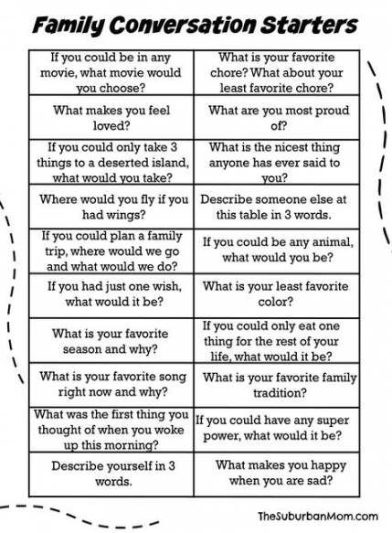
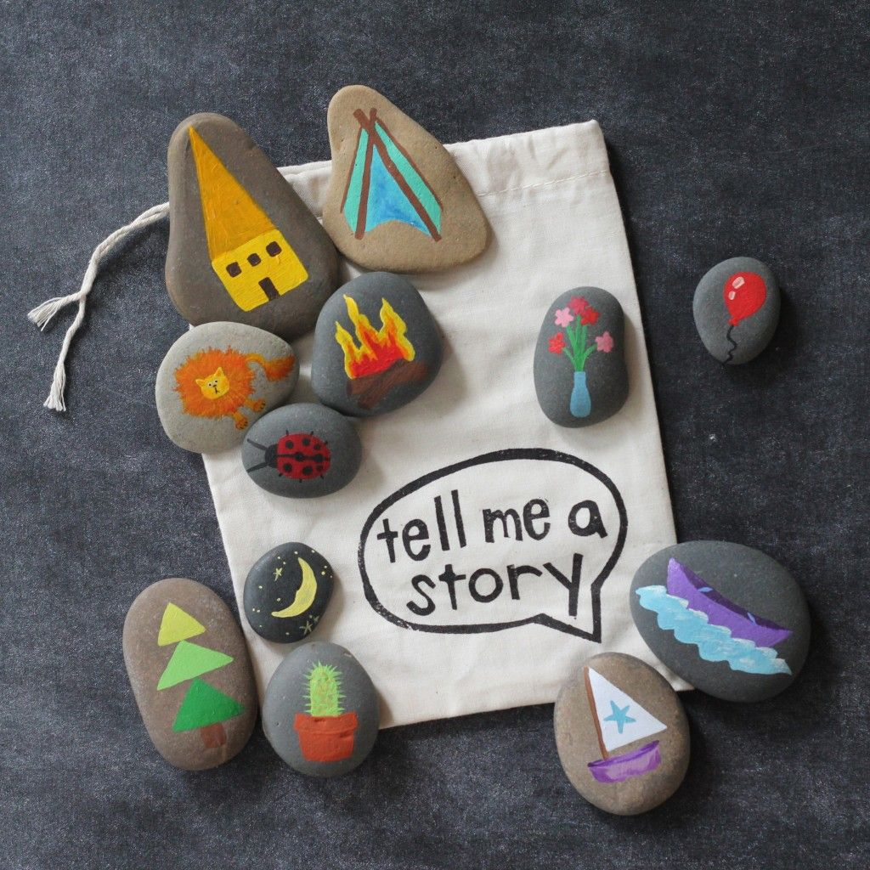

Kindergarten Readiness
We understand there will be a sense of uncertainty about Kindergarten readiness. Look to your school’s preschool and Kindergarten staff for support. Here are a few resources to use at home as well.

Ohio Dept of Ed Kindergarten Family Guide
Ohio Dept of Ed Kindergarten Readiness Checklist
Ohio Dept of Ed Early Learning Family Resources
Ohio Dept of Ed Social Emotional Development Resources
Get Ready to Read! Site link with Kindergarten transition toolkit
Kindergarten Readiness Checklist, by United Way Success by 6 Lancaster (via Pintrest)
Indicator Checklist, AR Better Beginnings
If your school hosts an iXL subscription, it is also a good source of practice

Create bingo cards for weekly activities using the above checklists
